SOLUTION ARCHITECTURE

**IoT Based Safety Gadget for Child Safety Monitoring and Notification**

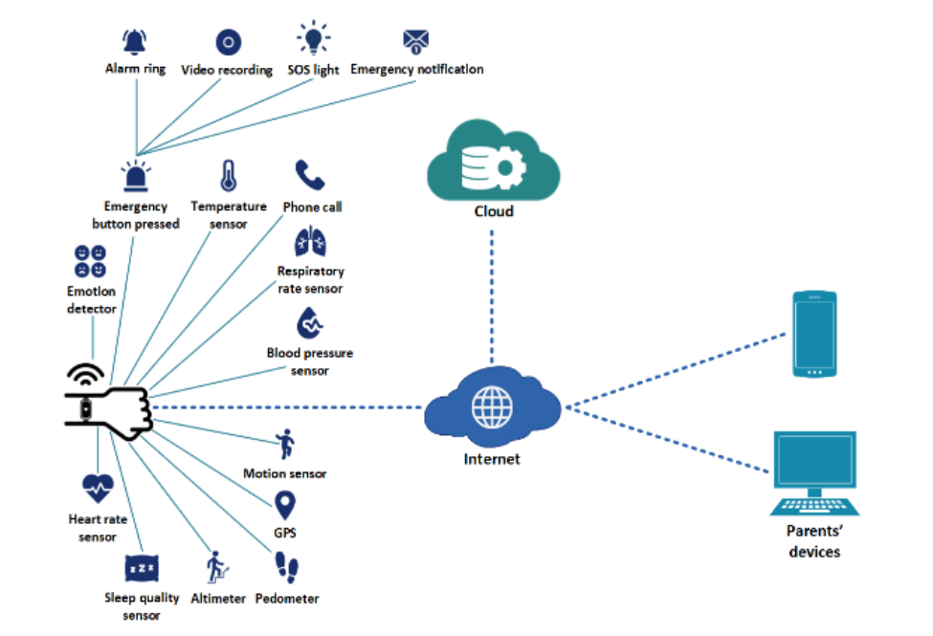

DESCRIPTION:

ALARM RING:



The security system sends an alert to your phone whenever it detects activity. Arming the system determines which types of alerts you get. If you have a Ring Protect Plus plan with professional monitoring, the monitoring center calls the police after checking for false alarms.

VIDEO RECORDING:



This feature enabling you to surreptitiously record videos for monitoring.

SOS LIGHT:

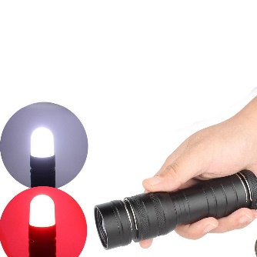

‘SOS’ is an international code signal for extreme distress and an urgent appeal for help.

EMERGENCY NOTIFICATION:

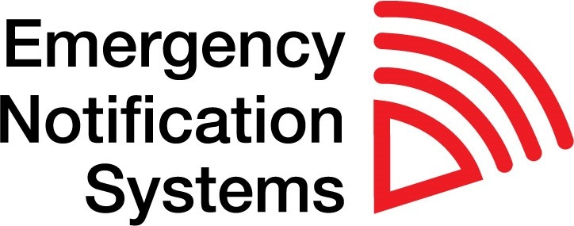

An emergency notification system is an automated method of contacting a group of people within an organization and distributing important information during a crisis.

EMERGENCY BUTTON PRESSED:

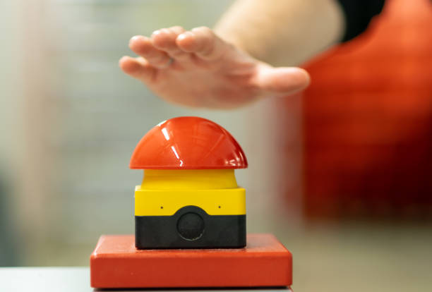

An emergency stop push button is a safety device.

TEMPERATURE SENSOR:



Temperature sensors are devices used to measure temperature. Most of the temperature sensors we supply monitor temperature by measuring the change in resistance of an electrical current.

PHONE CALL:



Bluetooth smartwatch with call function eliminates the need for your smartwatch to be connected to your earpiece in order for you to listen in and speak on the call.

RESPIRATORY RATE SENSOR:

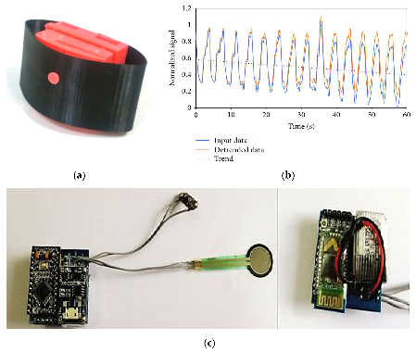

Respiratory rate can be extracted from airflow as expiratory air is warmer than inspiratory air. In addition, the pressure of the airflow can be used to extract the respiratory signal. To monitor patients breathing, a sensor attached to the airways is required to measure the changes in these parameters.

BLOOD PRESSURE SENSOR:

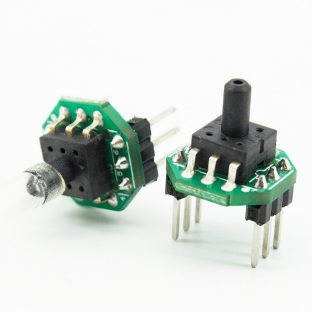

The Blood Pressure Sensor is a non-invasive sensor designed to measure human blood pressure. It measures systolic, diastolic and mean arterial pressure utilizing the oscillometric method. Pulse rate is also reported.

MOTION SENSOR:

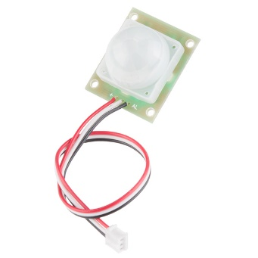

A motion sensor, or motion detector, is an electronic device that uses a sensor to detect nearby people or objects. Motion sensors are an important component of any security system. When a sensor detects motion, it will send an alert to your security system, and with newer systems.

GPS:



The GPS helps enhance safety and fitness features on the watch. Depending upon the watch, it can alert authorities about your location in case of an emergency and help track your route duration and distance while running, cycling, or doing other outdoor activities.

Pedometer:

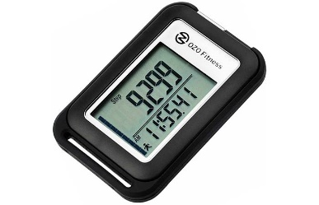

This feature helps you in calculating your step count on a daily basis.

ALTIMETER:

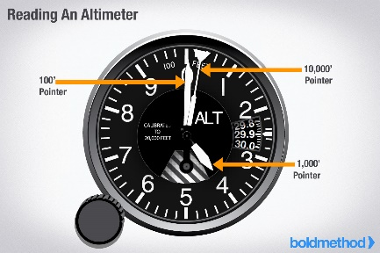

An altimeter is a function in watches that helps measure the altitude. By measuring the atmospheric pressure, the watch is able to measure the altitude above sea level or a relative fixed point and provide the information in either feet or meters.

SLEEP QUALITY SENSOR:



It is used for monitoring your body movements as you sleep to determine how much time you probably spent awake versus asleep.

HEART RATE SENSOR:



It helps in monitoring your flow of blood from your heart. It calculates the heart beats per minute as when the blood from your heart flows, it reaches your artery and is reflected on your wrist.

TEAM ID: PNT2022TMID37952

TEAM BATCH NO: B7-1A3E

MENTOR NAME: R. PADMAVATHY

TEAM LEADER: S. MADHUVANTHHI

TEAM MEMBERS: P. GLANY ROSE

V. POOJA

R. SANGEETHA

TEAM SIZE:4